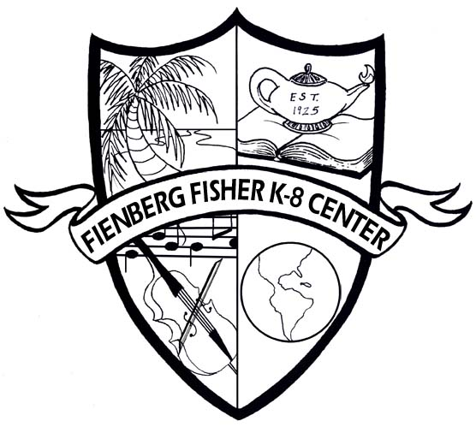
7th Grade Language Arts
Fienberg-Fisher K-8 Center
7th grade Summer 2013 Reading List

Incoming seventh graders must read two of the novels below assigned by the Reading/Language Arts Department. Students are also required to select and complete one of the projects for each of the novels chosen. Novel selections are determined by the grade level and IB program and recommended by the 7th grade teacher.

Tangerine by Edward Bloor
Choose ONE of the following projects. This project is a REQUIRED assignment. Projects are due the first week of school.
Option #1: Create a list of three characters from the novel. Under every character’s name, you need to provide a list of adjectives that describe all of the characteristics (strengths and weaknesses) of the character. A supporting quotation and the page number must accompany every adjective.
Option #2: Compare and contrast the qualities between the two brothers, Paul and Erik. Draw a poster size Venn diagram depicting a comparison and contrast between the lives of these two boys.
Option #3: Select captivating quotations that you can use to persuade a prospective reader to choose Tangerine. Create a book jacket and incorporate the quotations.

The Outsiders by S.E. Hinton
Choose ONE of the following projects. This project is a REQUIRED assignment. Projects are due the first week of school.
Option #1: Select captivating quotations that you can use to persuade a prospective reader to choose The Outsiders. Create a book jacket and incorporate the quotations. See Directions below.
Option #2: Compare and contrast the 1960s gangs in the novel to modern gangs today. Create a Venn diagram poster using pictures and writing details of the differences between the 1960s gangs and modern gangs.
Option #3: People join gangs for many reasons and don’t realize the possible negative consequences. Write a two-page article discussing the negative consequences that the characters faced in the novel of joining gangs and use research from the internet, library, and other resources to support why joining gangs has negative consequences.

The Upstairs Room by Johanna Reiss
Choose ONE of the following projects. This project is a REQUIRED assignment. Projects are due the first week of school.
Option #1: Research the story of Anne Frank in the library, online, or in Anne Frank’s Diary. Draw a poster size Venn diagram depicting a comparison and contrast between the story of Anne Frank and the main character, Annie de Leeuw. Use quotations from the novel to support your statements and cite the source where you researched the information on Anne Frank.
Option #2: Research information on the history of the Holocaust. Create a poster using the history of the Holocaust and what you learned from the book. Please include information on the Holocaust, pictures, and quotations to create your poster.
Option #3: Pretend that you are Annie de Leeuw and you are trying to save your own life from the Nazis. Write a week of journal entries of how it feels to be hiding and escaping from the Nazis and what you and your family did to survive from the Nazis soldiers.

Book Jacket Directions:
1. Look at a minimum of five examples of hardcover book jackets before beginning this project. (Go to a library or any bookstore)
2. Using construction paper of whatever color you wish, design a book jacket. Fold the paper like the picture below. Fold it like a real book jacket (see sketch below).
3. You may create your book jacket by using the computer, by hand or using a combination of both.
4. Design your book jacket so it includes the information generally found on a book jacket (see information below).
5. Be original! Be creative! Use color! Use your imagination! Have fun!

